Predicting Road Traffic accident severity using XGBoost
Machine Learning Assignment 2
Name: Aryan Raheja
StudentID: 24956928

I acknowledge that I have used AI to assist with the planning, development and debugging of this task. Below you can find the link to my conversation with chatgpt:

https://chatgpt.com/share/68e615c7-eec4-800b-a76e-8770bdd2ec51

Collab link (It is noted that a zip file will also be submitted with the dataset linked to run the program if needed):

https://colab.research.google.com/drive/1h3S4IovpL2o3PZNpPykAviXCLxHLASTG?usp=sharing

Predicting Road Traffic accident severity using XGBoost 1
Problem Statement: 3
Objective: 3
Dataset Source and Collection: 3
Data exploration: 4
Data dictionary: 4
Initial findings and challenges: 6
Missing Values: 6
Heatmap to show missing values: 8
Missing information/context: 8
Preprocessing: 8
Missing values: 8
Unknown vs Mode of data: 9
Mode: 10
Unknown: 10
Encoding: 10
Training and testing: 11
Model Architecture: 12
Decision trees in XGBoosting: 13
Loss function: 14
Motivation: 14
Metrics evaluation: 15
LogLoss graph 15
Logloss statistics 16
Classification report 16
Confusion matrix 17
Conclusion: 18
AI evaluation in this project: 19
References: 20

Problem Statement:
Road accidents are a major global concern, leading to injuries, fatalities, and significant economic losses. In the calendar year of 2024 Australia experienced 1291 fatalities linked to road accidents (DITRDC, 2025). As these accidents are unavoidable, a look into the severity of each accident can greatly help in emergency response times, prioritizations of casualties and helps transport departments identify high-risk conditions. I aim to use Ai’s assistance in understanding concepts and building the model.

Objective:
The objective is to build a machine learning model aiming to classify the severity of an accident into slight injury, serious injury or fatal injury. Utilising a data real world messy dataset we will use factors such as driver demographics, vehicle characteristics, road conditions, and environmental variables to classify cases into their respective level of severity. The final result will aim to show the factors that influence the more dangerous accidents prompting appropriate measures to be put in place that may reduce their severity.

Dataset Source and Collection:
The dataset for this task has been sourced through Kaggle. Kaggle is a data science competition platform full of datasets and Machine learning resources. The Dataset that has been chosen is an Accident prediction Dataset (Aditya Akuskar, n.d., RTA Dataset). The dataset has many factors that influence severity of accidents such as road alignment, weather condition, cause of accident and many more that will be useful in training the model. The main reason this dataset was selected was due to it having missing values and inconsistencies that will require careful preprocessing to ensure data quality and reliable model performance. As for coding the assignment Google collab will be used. This is due to having prior experience and its ease of sharing.

The reason behind choosing this dataset came down to the requirement of this task. I wanted to do option 2 of this task designing a real world application as it would help me understand the process of an actual project which I do find more valuable compared to deep diving into the theory of how AI models work. I also deemed that this type project would stand out better on a resume leading to better career opportunities in the future. A requirement for this was to find a “Messy” dataset that would have more missing values and would require more data preprocessing which would then allow us to use the models straight from the library. Therefore I deliberately chose a dataset that required more preprocessing to fit the requirements of the task.

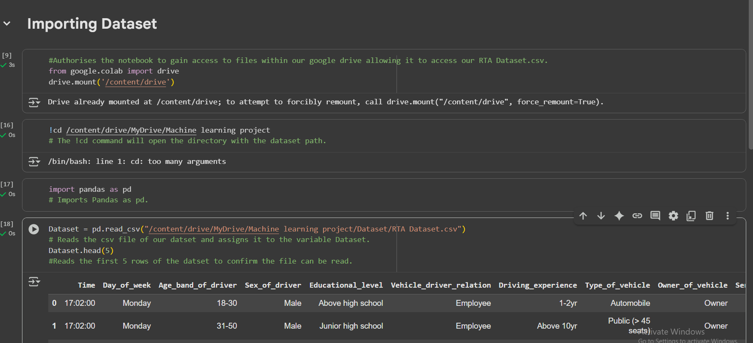
(Figure 1)

The above figure shows the process of importing the dataset into the collab file. First giving it access to the drive and using the !cd command with the path to the directory of the dataset. With the pandas library we can read the dataset and assign it to the variable dataset to begin the preprocessing section.

Data exploration:

Data dictionary:

Attribute | Attribute Type | Explanation/justification | Example
Time | Date/time | The time in which the accident occurred. | 17:05:00.
Day_of_week | String/categorical | The day of the week the accident occurred. | Monday.
Age_band_of_driver | String/categorical | A split binned age range the driver was part of. | 18-30.
Sex_of_driver | String/categorical | The gender of the driver. | Female.
Educational_level | String/categorical | The highest level of education achieved by the casualty. | Junior high school.
Vehicle_driver_relation | String/categorical | Employment status of casualty. | Owner.
Driving_experience | String/categorical | A split binned range for the casualties driving experience in years. | 5-10yr.
Type_of_vehicle | String/categorical | The type of vehicle being driven during the accident. | Automobile.
Owner_of_vehicle | String/categorical | The state of ownership for the vehicle | Owner.
Service_year_of_vehicle | String/categorical | The service year of the vehicle is sorted into binned categories. | 2-5yrs.
Defect_of_vehicle | String/categorical | States whether a vehicle has a defect or assigns a number to refer to its defect. | No defect.
Area_accident_occured | String/categorical | The type of area the accident occurred. | Residential areas.
Lanes_or_Medians | String/categorical | The type of lane or median the vehicle was driving across. | Undivided Two way.
Road_allignment | String/categorical | The alignment of the road the vehicle was driving. | Tangent road with flat terrain.
Types_of_Junction | String/categorical | The type of junction the accident occurred. | Y Shape.
Road_surface_type | String/categorical | The material/type of road the vehicle was driving on. | Asphalt roads.
Road_surface_conditions | String/categorical | The type of condition that may have been affecting the road. | Wet or damp.
Light_conditions | String/categorical | The lighting around the accident to understand visibility of the driver. | Daylight.
Weather_conditions | String/categorical | The weather during the time of the accident affected the driver. | Raining.
Type_of_collision | String/categorical | The type of collision that would have caused the accident. | Vehicle with vehicle collision.
Number_of_vehicles_involved | Numerical/Integer | The number of vehicles that are affected from the incident. | 2
Number_of_casualties | Numerical/Integer | The number of casualties from the incident | 3
Vehicle_movement | String/categorical | The movement of the vehicle that caused the incident. | Moving Backward.
Casualty_class | String/categorical | The casualties role in the incident. | Pedestrian.
Sex_of_casualty | String/categorical | The gender of the casualty. | Male
Age_band_of_casualty | String/categorical | A split binned age range the driver was part of. | Under 18.
Casualty_severity | String/categorical | Severity of the casualty's injuries represented by a number ranging from 1 to 3 with 3 being the most fatal. | 2
Work_of_casuality | String/categorical | The employment status of the casualty. | Employee.
Fitness_of_casuality | String/categorical | The fitness of the casualty. | Normal.
Pedestrian_movement | String/categorical | The movement or action of pedestrians if they were a factor to the crash. | Crossing from the driver's nearside.
Cause_of_accident | String/categorical | The cause of the accident. | Moving Backward.
Accident_severity | String/categorical | The severity of the accident classified into slight, serious and fatal. | Serious Injury.

Initial findings and challenges:

This section aims to show the initial findings and challenges that were found in the dataset to be preprocessed before training and testing.

Missing Values:
The initial findings of the dataset showed missing values in multiple columns, To better see the missing values present in our dataset the following code was used.

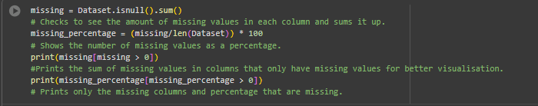
(Figure 2)
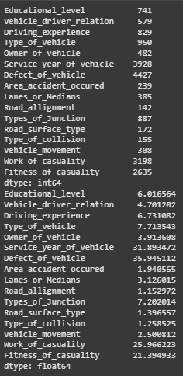  (figure 3) | - The line of code will check to find the missing values of the dataset and find the percentage of each column missing. Furthermore it will print out only the columns that are missing values and the percentage that are missing.  - Most columns range from 1% - 8% of data missing which is manageable as they can be replaced depending on their attribute type.  - There are 4 main outliers in the database Service_Year_Vehicle, Defect_of_vehicle, Work_of casualty and fitness_of_Casualty. These columns have between 21%-35% of missing values.  - These missing values will be handled in the preprocessing stage.

Heatmap to show missing values:
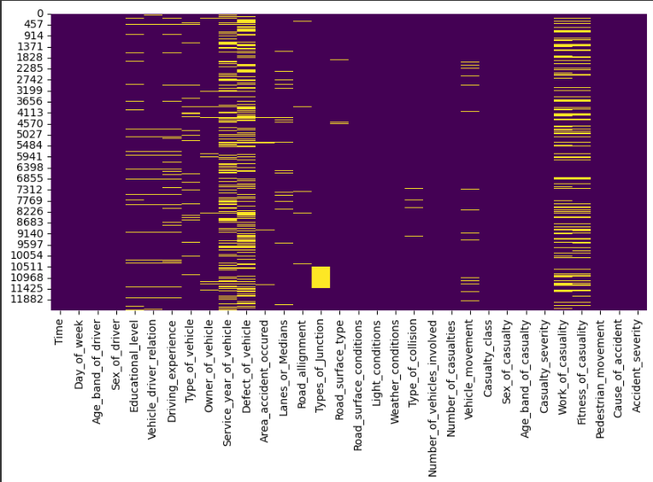
(Figure 4)

Missing information/context:
Upon analysing the dataset there appears to be columns with crucial metadata missing that helps understanding the role these columns will play. For example in the defects of vehicle column a defect of a vehicle is noted either having no defects or a specific number assigned to that defect such as 3 potentially meaning engine problems. However the dataset does not provide a key or legend as to what these numbers would refer to therefore we cannot incorporate specific defects into our model for training and testing.

Preprocessing:

Missing values:

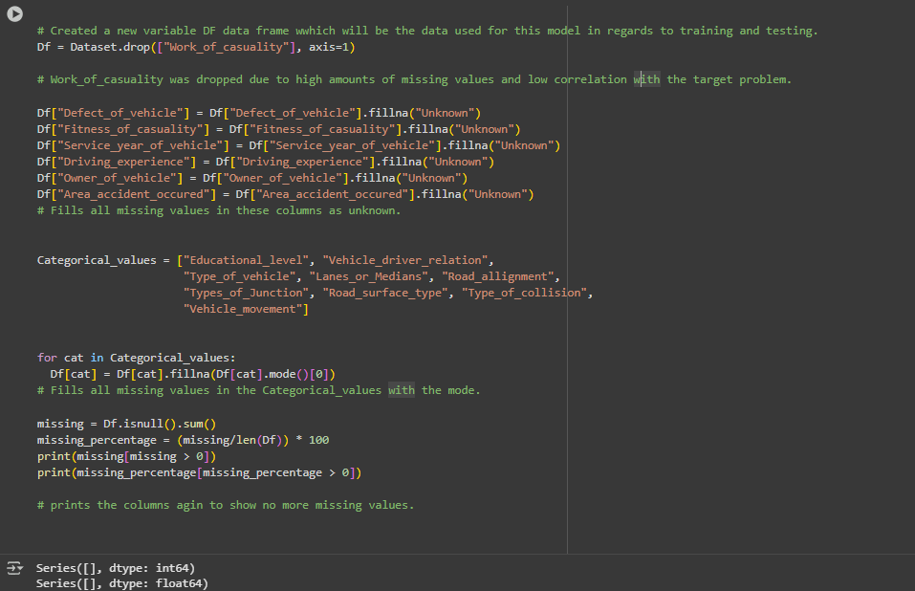
(Figure 5)

To fill in missing values, columns needed to be evaluated based on the type of data they would need to be filled on and their correlation to the problem statement. Missing values are essential to deal with as Ai algorithms will require complete datasets to work with.

- A new variable of DF was created to store the preprocessed database that will be used to train and test the model.

- The work_of_Casualty column we dropped due to the fact that it had one of the highest percentages of missing values at 25.97% and had low correlation to the target problem. While there were 3 other columns that had large amounts of missing values they had more correlation to the target problem which is why those values would need to be filled/replaced

- Due to no nominal columns containing missing values with the only values containing numbers having been binned they would be considered categorical when filling in missing values.

Unknown vs Mode of data:
With all columns being categorical values there had to be decisions on which of the columns should be replaced with “Unknown” or the mode. With the help of ai i was able to greatly understand what columns required what form of replacement.

Mode:
The mode is the most common value that appears in the dataset. Columns such as Education_Level, Type_Of_Vehicle, Vehicle_Driver_Relation will have low amounts of variance in their columns with answers such as “high school” or “Car”. These columns also saw missing values >10% which means filling these missing values will not affect the final output as much. Mode imputation keeps them realistic.Therefore it is more suitable to replace these values with the mode as mode won’t distort the distribution too much and the model can still learn patterns without introducing “fake” categories.

Unknown:
The other option for these missing columns was to fill them with an “Unknown” string value. Columns such as "Area_accident_occured", "Owner_of_vehicle", "Fitness_of_casuality" are more context-sensitive or have higher missing values, meaning missing values might carry meaning. Using "Unknown" allows the model to learn from the fact that this info was missing, instead of forcing an assumption.

The DataFrame was printed out again to ensure all missing values had been replaced and could now move onto encoding.

Encoding:
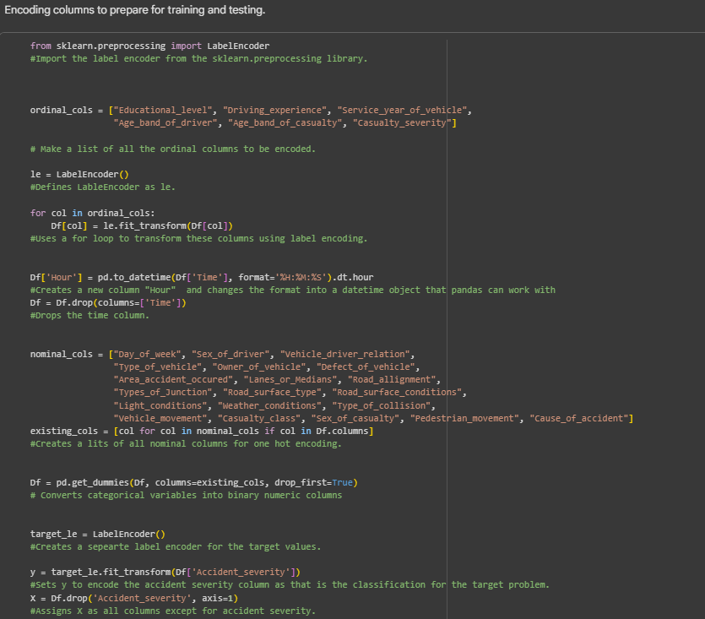
(Figure 6)

Encoding is essential as the model architecture for XGBoost can only process numeric inputs. It transforms categorical text into numbers, so the model can process and learn patterns correctly.

Importing the sklearn.processing library allows us to access the labelencoder. The label encoder is essential to transforming categorical labels into numeric codes. This process will be essential to changing the data for our model to work.

Columns were separated in the dataset in accordance to how theory will be encoded. The first step was to extract all the ordinal columns in the dataset, this being columns that have a natural order or hierarchy in which we can encode an order. For example in education level within education level you will find fields ranging from “Junior high school” and “Above high school”. The labelencoder will assign these values with 0 and 1 in alphabetical order. Some of these columns are also in binned categories which would fit the criteria for it to be ordinal. The next step is using a for loop to change each column in the ordinal list into numeric values ready for the model to use.

The time column within the dataset was in the format of ##:##:## to tell us the time the accident occurred. However this cannot be read as a numeric value within our model and therefore has to be converted. The conversion of this was done by first introducing a new column by the name of hour then taking the time in each field and rounding it to the nearest hour. For example the time of an accident being at 20:45:00 would be changed to 21 representing the 21st hour of the day. Doing this transformation allows us to convert the time into a readable input for the model without getting rid of it as it is an essential column for the nature of this task. The time column was then removed to avoid the model reading it and throwing an error.

The nominal columns list consisted of columns that were categorical however did not follow a natural order in its fields. To make these features suitable for model training, one-hot encoding was applied using the pd.get_dummies() function in pandas. This process converts each category into a new binary column, indicating the presence of that category. For example a column like Road_surface_conditions with categories such as Dry or Wet or damp would be transformed into three separate binary columns Road_surface_conditions_Dry or Road_surface_conditions_Wet_or_damp. The parameter drop_first=True was included to avoid the dummy variable trap to avoid redundancy. Therefore with this process we can ensure that all categorical columns within the nominal list can be represented numerically for the mode.

The final stage of encoding dealt with our target variable. To do this a new labelencoder was created with the name of target_le. This was so that there would be no overlapping between the two encoders. A new variable y was assigned to the encoding of our target column being accident severity where it would breakdown “Slight injury”, “Serious injury” and “Fatal injury” into numeric identifiers being 0,1,2. The second variable x was assigned all columns excluding the target variable. These would become our target variables that would be fed into the final model.

Training and testing:

The final process of the data preprocessing stage was assigning the amount of data that would be used for training and testing the model.

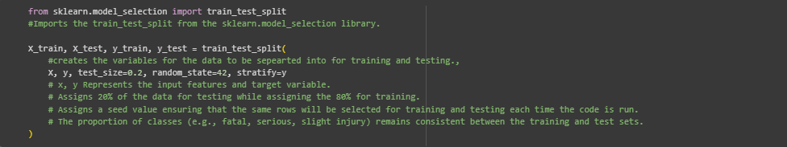
(figure 7)

The first step was to import the train_test_split function from the sklearn.model_selection library. The function will assign a necessary amount of data for both training and testing depending on its parameters. 4 different variables were created to assign the training and testing data for both the input features and target variables. 20% of the data was allocated for testing leaving the rest (80%) for training the model. A random state of 42 ensures that the same rows will be selected for training and testing each time the code is run. The final steps required the proportion of classes (e.g., fatal, serious, slight injury) to remain consistent between the training and test sets. Now after preprocessing all necessary components are complete to start implementing and training the model.

Model Architecture:
The model that was used to perform the target problem as mentioned previously was XGBoost (extreme Gradient Boosting). This model builds an ensemble of decision trees but does so in a more optimized way compared to something like random forest. It does this by first making a prediction for every sample trained or tested. In the context of this model if 80% of the classifications are “Slight injury" the model will then start predicting slight injury for everyone. The next step after that is to start working through the errors by making the decision trees. The following code for the XgBoost classifier is shown below.

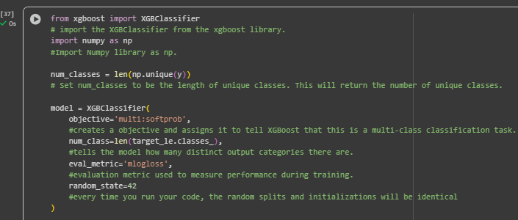
(Figure 8)

The above figure is the architecture to run our model using specific parameters to achieve the target output.

- The first step is to import the XGBClassifier from the XGBoost library for the multi classification task. Numpy was also imported so that data can be read and processed numerically.

- Num_classes was created and assigned to the length of unique classes within the target variable. This is important to count the number of categories there are. e.g. ['Fatal Injury', 'Serious Injury', 'Slight Injury']. This also further enforces the idea that it is a multiclass classification.

- Now we start building the classifier and specifying the parameters. The first step of this was to set the objective variable to 'multi:softprob'. This will tell the model it is working with a multiclassification task. It will then output a probability distribution for each class. An example of this could be (P(Fatal)=0.1, P(Serious)=0.3, P(Slight)=0.6). By then optimizing logarithmic loss (cross-entropy) it will penalize incorrect predictions the more confident it is.

- Setting the num_class to be the length of the target variable will tell the model how many distinct output categories there are. Doing this XGBoost will build 3 separate sets of decision trees, one for each class. By doing this it can create predictions across trees to classify the final result.

- The eval_metric is set to ‘mlogloss’ (Multiclass Logarithmic Loss) to measure performance during training. This function will help measure how close the predicted probabilities are to the true labels. With lower mlogloss resulting in better predictions. With the random state being set to 42 again to enforce the random splits and initializations to be identical.

Decision trees in XGBoosting:

As the XGBoosing is made up of decision trees in this process we shall discuss their role in this multiclassification process. The model starts by predicting a baseline probability classifying by the most common predictions. This will cause a lot of errors due to misclassification of many values which will then be minimized by decision trees. I used Ai to breakdown decision trees role in XGBoost to better understand the concepts.

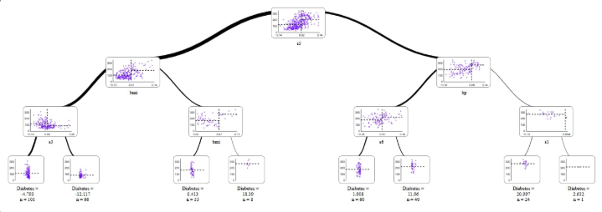
(Figure 9: Visualization of an XGBoost decision tree, adapted from MLJAR, 2021)

XGBoost calculates the gradient of the loss function and starts building decision trees to try and counter the errors. A decision tree is built where each node is split to maximize information gain. It will split based on the gradient identifying the best feature to split on. At this stage XGBoost trains many small trees sequentially, with each tree correcting the tree that comes before it. For example the broad classifications might label a driver > 60 as serious injury. However when the decision tree considers the accident to be night time and raining it may classify this accident as a fatal injury. All these trees would be combined and summed up to produce the final output.

Loss function:
The loss function for this task is the multiclass logarithmic loss. This function aims to measure the predicted possibilities and how much they diverge from its true labels. The mathematical formula for this can be represented through the figure below. With the help of ai i was able to fully understand how this function works in the context of my project design.

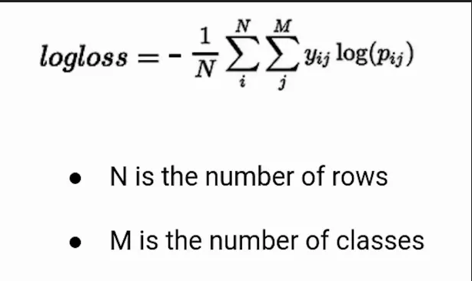
(Figure 10: Analytics Vidhya. (2021, March).)

This function helps classify the logloss of this project where N = the number of samples and M = number of classes. Yij’s value depends on Pij as Yij will be 1 if Pij is the class that is assigned as the class when the model makes broad predictions. For example when the model makes a broad prediction at the start of the decision trees, if after more decision trees it is confirmed to be part of the class Yij will assign itself as 1 else it will assign itself as 0. Therefore that means Pij is the class.

Motivation:
My motivation for choosing XGBoost is due to the fact I have used many classification models before in previous subjects such as logistic regression, decision trees, random forest, neural networks etc. Therefore for this task I chose to use something different to learn about and expand my knowledge on more ai models.

Metrics evaluation:

LogLoss graph

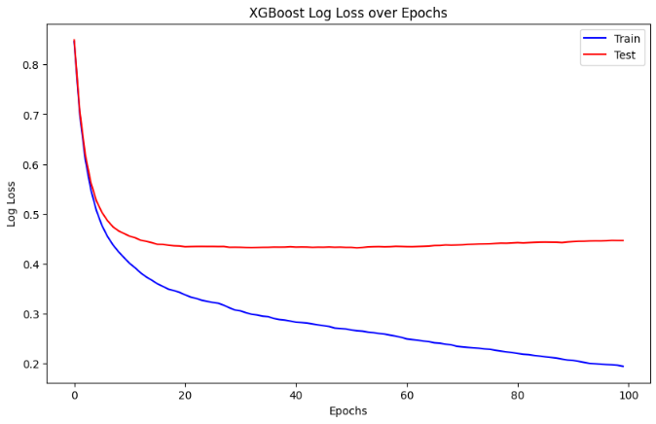
(Figure 11)

The above figure is the log loss curve which aims to show the model's performance throughout the training process. An epoch in the context of our model is the boosting of an iteration meaning it adds a new decision tree to fix a previous error from previous decision trees. As training progresses, the model incrementally minimizes the log loss by improving its ability to correctly classify accident severity levels.

Looking at the figure we can see that the training log loss is following a downward trajectory. This is positive for our case as it shows that the model is successfully learning patterns with the training data. As the curve begins to flatten the model begins to show less return. Therefore suggesting that more training contributes less improvements in model accuracy. Another observation that can be made is that after around 0.4467 log loss, the test curve begins to flatten, This therefore shows that the model has reached a point of convergence further suggesting less improvements with more training. The use of ai was especially important in making this graph in assisting its creation.

Logloss statistics
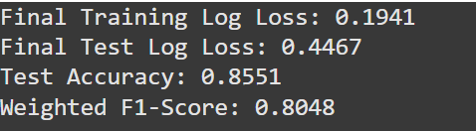
(figure 12)

The above figure allows us to get a more in depth view of the graph's performance. The final test log loss and the training log loss aims to show the gap between both endpoints of their values when reaching 100 epochs. This gap shows the model. learned meaningful patterns from the data (since both values are reasonably low) and that it performs better on training data than it does on unseen data. The model had a string accuracy score with an 85.51% accuracy in correctly classifying the seriousness of an injury. This is further shown with a 80.58% f1 score suggesting that XGboost gives a solid accuracy in correctly classifying these values.

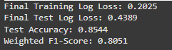
(figure 13)
Another test was done where 15% of the data was used for testing where we can see a smaller gap between the final test log loss and the training log loss. I Used ai to further breakdown the metrics as to why having 20% for testing is better than 15%. We see a lower accuracy score suggesting the model may have had less diverse test data. Therefore for the final evaluation we decided to go with 20% for testing.

Classification report

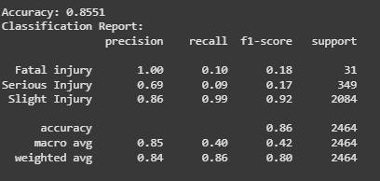
(figure 14)

The classification report further gives insights on the models accuracy. Breaking down the accuracy of predicting between all 3 classes some interesting trends begin to emerge.

Having a look at slight injury classifications the result we achieve a 0.86 precision suggesting that the model predicts slight injuries 86% of the time. However it has a 0.99 recall score suggesting 99% accuracy in predicting all true slight injury cases. Followed by a 0.92 f1 score we can see that the model is incredibly effective in predicting slight injuries. Another observation that can be made is that considering slight injury is the most common outcome XGBoost will set all its initial predictions to slight injury before starting to correct itself.

Looking at serious injuries we can see some class imbalance. While it has a 0.69 precision it unfortunately has only a 0.09 recall. This with a 0.17 f1 score suggests that the model may struggle to identify serious injuries due to similar correlation with slight injury as well as the outcome appearing far l;ess frequently compared to slight injury. Therefore in this scenario XGBoost will classify a majority of these values as a slight injury, the most common and initial prediction causing some imbalance in the final performance of the model.

With Fatal injury, the model has a precision of 1.00, however a 0.10 recall and 0.17 F1-score. This suggests that fatal injuries happen far less frequently than the other two categories, and while the model rarely predicts them, when it does, those predictions are always correct. Although it doesn’t capture many fatal cases overall, having a precision of 100% means the model is highly reliable when it identifies one. This is important to know, as our objective is to help identify the seriousness of injuries. Being able to correctly detect fatal injuries with complete precision helps introduce measures that may reduce their severity. A greater visualisation of this can be seen in the confusion matrix below.

Confusion matrix

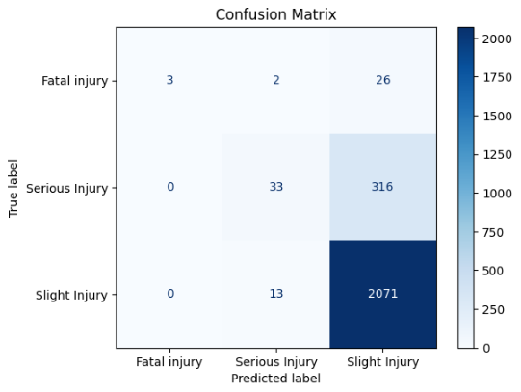
(figure 15)

The above figure shows the number of predicted labels to their actual true label. A confusion matrix is incredibly useful in visualising the accuracy of our model as well as evaluating its performance. The hue in colour shows the more values for that specific prediction. In total we can see that 20% or 2464 values were tested and can see out of those 2071 ended up being slight injuries that were predicted to be true. With approximately 84% of the data successfully assigning itself as slight injury we can infer it being the most common class or injury that can result from a car accident. We can however see 315 of these values being misclassified being serious injuries when they were actually serious injuries. This goes back to the low recall score received in which the model may have a harder time distinguishing a serious injury to a slight injury due to higher correlation between the two. As we can see the lack of fatal injuries being predicted compared to actually getting it true is 100% accurate. Therefore this confusion matrix provides a good narrative into how the model works and its accuracy through useful visualisation.

Conclusion:

Ultimately the initial target problem aimed to create a model that can classify accidents based on their severity was done reasonably well through the use of XGBoost. After dealing with messy data and preprocessing it by encoding we were able to filter data readable to XGBoost allowing it to classify accidents into either slight, serious or fatal accidents. The model achieved an 85.51% accuracy in classifying into one of the 3 classes based on training with 80% of data and testing with 20%. While different amounts of training and testing data were experimented while also modifying learning rate, it was concluded that this train test split achieved the highest accuracy.

This project has a lot of potential for future work as more fine tuning and collecting more data may be able to increase the accuracy of the model. However due to low recall in the fatal and serious injury predictions more fine tuning to identify fatal accidents. By continuing to refine the preprocessing and parameter tuning process, the model could provide even more reliable predictions of accident severity, ultimately contributing to the original goal of improving accident classification and supporting better road safety analysis.

AI evaluation in this project:
Ai contributed a lot to my learning for this specific task. As I have never used XGBoost before, Ai has helped me greatly understand the core concepts and functionality of this model. Ai also helped greatly in solving errors in my code and giving me advice on the proper structure this report should be written in. With the help of ai i was able to deduce that while the accuracy of the model is relatively high due to low recall in both my serious injuries and my fatal injury classes the model may not achieve the greatest usefulness just yet. Therefore future study and fine tuning would be required to make the model feasible in a real world scenario . Overall Ai has assisted me greatly in this assignment and makes me realise the impact/assistance Ai will have within this field in the future making working more efficient and accurate.

References:
Analytics Vidhya. (2021, March). Binary cross entropy / log loss for binary classification. Analytics Vidhya.
https://www.analyticsvidhya.com/blog/2021/03/binary-cross-entropy-log-loss-for-binary-classification/
(DITRDC, 2025). Monthly road deaths. https://datahub.roadsafety.gov.au/progress-reporting/monthly-road-deaths
Akuskar, A. (2025, February). RTA dataset: Accident prediction dataset. Kaggle. https://www.kaggle.com/datasets/adityaakuskar/accident-prediction-dataset
MLJAR. (n.d.). Visualize XGBoost tree.
https://mljar.com/blog/visualize-xgboost-tree/
OpenAI. (2023). ChatGPT (GPT-4) [Large language model].
https://openai.com/chatgpt

